To: Dr. Armin Eilaghi

CC: Connor Gaudette

From: The Flying Squirrel Team

Date: 9/10/2025

Re: Project Management

**1. Top Level Design Summary**

At the beginning of last semester, our group was tasked with building a robot to stimulate arm motion in recovering stroke patients. While this itself is not a novel concept, our client wanted a device that is more affordable, compact, and relatively simple than anything on the market. A previous team offered a solution that addressed these requirements but was unable to provide vertical motion. This design used effective but cumbersome omnidirectional wheels, which our client forbade on the new design. Instead, our client, Dr. Razavian, proposed the use of cables attached to anchor points to pull our robot in any necessary direction. From there, we devised a system of three cables at 120-degree intervals to achieve horizontal motion. This we combined with two lead screws positioned to raise and lower the user’s hand. Other, less significant components include the roller bearings on which the robot stands, and the screen for selecting what motion routine the robot will follow.

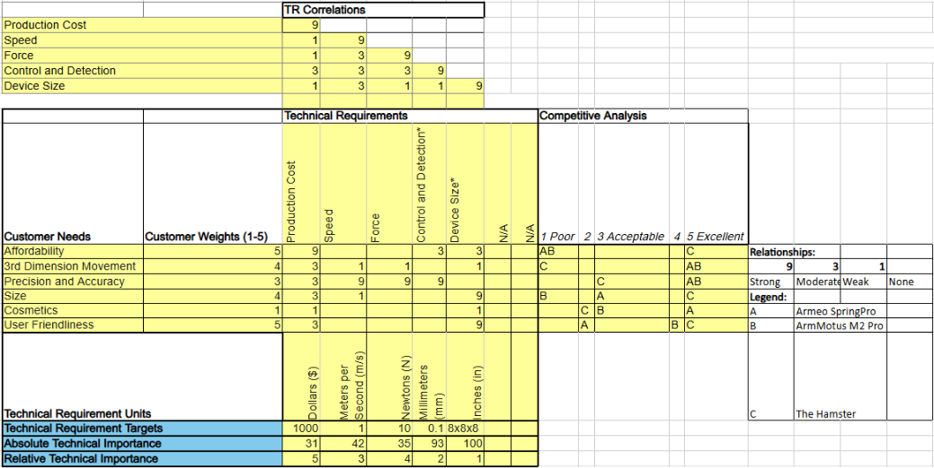

Figure 1: QFD

Though our design still upholds the crucial engineering requirements first laid down by our client, certain conditions are proving unfeasible as we continue the assembly process. Dr. Razavian is allowing us some latitude with these requirements. For instance, while our design still fits within an 8”x8” top-down area, we have exceeded the 8” height limit with the lead screws. Additionally, in purchasing components we have realized we will not be able to remain within the $1000 production cost limit. We have discussed this budgetary issue with our client, and he has agreed to increase it. However, we are on track to fulfill the other design requirements. These include the movement speed in any direction (1 meter/second), the force produced in any direction (10 Newtons), and the position tracking accuracy (Up to 0.1mm).

Many of the customer requirements are related to, but not as specific as, our engineering parameters. While our final model will not fall within the stipulated $1000 cost, it will still be comparatively affordable among similar devices. Its compact size will also put it above other stroke rehabilitation devices, even its predecessor. Other requirements, like 3-dimensional movement, precision, and accuracy, will be assured by our falling within the respective engineering requirements. The cosmetic aspect of the design, while somewhat subjective, essentially means that our device looks both reliable and safe to use. User friendliness means that our device is easily utilized by stroke patients, which we have assured with features like an adjustable grip and wrist strap.

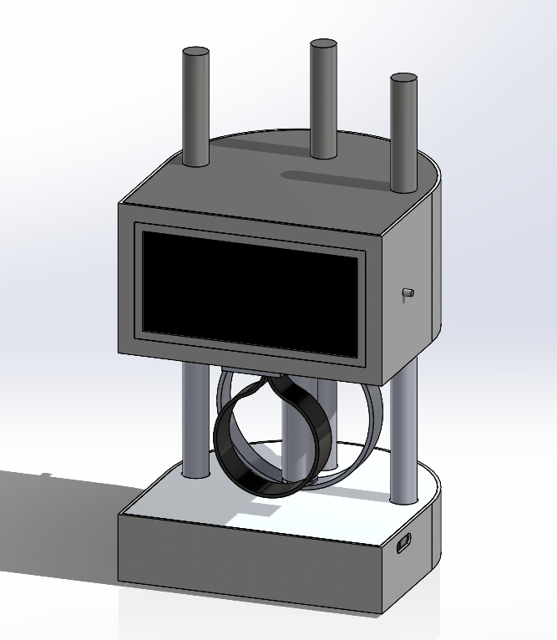

Bottom

Assembly

Grip and

Wrist Strap

Lifting

Screw

Touch

Screen

Cable Outlet

Top Assembly

Top Assembly

Figure 2: Top Level CAD Design

**2. Standards, Codes, and Regulations**

For Standards and codes, the main recognized body we would have to recognize is the International Electrotechnical Commission (IEC) as for the main regulation body that would impact us here in the United States is the Food and Drug Administration (FDA). The IEC prepares and publishes international standards for all electrical, electronic and related technology, which would include our robot. The IEC encompasses a lot of different fields but the overarching section that would apply is IEC 60601-1-11:2019 Requirements for medical electrical equipment and medical electrical systems used in the home healthcare environment [1]. But if we want to get granular the section that has the most relevance to us and our project would be IEC 80601-2-78:2019 [2] which focuses on basic safety and essential performance of medical robots. More specifically it focuses on robots with that perform or support Rehabilitation, assessment or alleviation related to any patient movement function. Though I would advise at this stage to hold off and wait one year as it seems they release new standards every five years and they released a new standard in 2020, so an updated version is due for 2025.

As for the FDA and regulations, we would need the Flying Squirrel to gain premarket clearance if we wanted it to enter the market. We would most likely be scrutinized as class 2 moderate risk devices. More specifically we could fall under the “interactive rehabilitation exercise device” umbrella according to the FDA website that includes “A prescription device intended to provide interactive rehabilitation environment by providing exercises for users to perform.” [3]. As for what standards they use to evaluate it they would they use IEC’s so the standards I have listed above would apply here in terms of our regulations.

**3. Equations and Solutions**

**3.1 Attachment Cable and Motor System**

* **Wire Tension-Jonathan A. and Justin J.**
  + ∑MA = 0

We selected this basic equation to discover the tension in the pulling cables necessary to keep the device stable when the anchors are 12” away. This was found to be 2.2 pounds force.

* **Maximum Motor Torque Estimates-Joey M. and Justin J.**
  + τ = F*r

For the horizontal cable motors, we used the diameter of a winch and the required force of 10 Newtons to calculate what torque each motor would need to generate. The result was around 0.127Nm, and the motors in our design were selected on this basis (This would initially include a 2x factor of safety, but this was later done away with).

* **Wire Max Stress-Jonathan A.**
  + S = (F*nf) / A = (T*nf)/ A

Based on the necessary force being generated by the robot, this equation was used to judge the maximum stress developed in each pulling cable. This was found to be about 31,567MPa, including a 1.2 factor of safety that was later deemed unnecessary. When done without the factor of safety this came to 26,308MPa. Our team accordingly chose a variety of cable that would easily withstand this stress with extended use.

* **Pulling Force for Four Wires-Owen K.**
  + F_c=√((0.5(dA-0.1437m) )^2+(dr+0.0298m)^2 )/((dr+0.0298m))∗5N

The conditions that led to the load case for these calculations were, they had to withstand a force of 10 Newtons, the required force set by the client. This calculation examined if a set of four cables and motors would not be better for the purpose of horizontal motion. Specifically, it looked at instances where the robot is being pulled in a path equidistant to two anchor points. The results indicated that the change in necessary force would be somewhat small- not enough to justify the extra components.

**3.2 Battery**

* **Total Battery Capacity Required-Ryan D.**
  + Ah = I * h

The conditions that led to the load case for battery capacity were, assuming that two of the three x-y position motors were operating at 100% load (8 amps) for the full run time and that the lift motor was operating at 100% load for one quarter (16 amps) of the total run time. With these assumptions in mind, total battery capacity came out to be approximately 12 amp-hours or 12000 mAh for just the motors but as there are other electronics operating as well as an extra 3 amp-hours was added to the capacity making for 15 amp-hours of capacity.

* **Total Voltage Required-Ryan D.**
  + V = RPM / KV

The conditions that led to the load case for the battery voltage finding the required RPM to meet the velocity requirement set by our client and diving that number by the voltage constant of the motor to find the necessary voltage to power the motor. With a necessary RPM of 3000 and a voltage constant of 330 for the motor, it gives a necessary voltage to drive the motors at 9.1 volts. This would require a 3S LiPo battery rated at 11.1 volts. This should give enough room for the voltage drop caused by having 4 motors connected to the battery.

**3.3 Lifting System**

* **Necessary Lifting Strength-Owen K.**
  + M = MPhmg(L(1-0.5Phl))+ MPfmg(L(0.5Pfl+Pal))+ MPamg(L(0.5Pal))

The condition that led to the load case for the necessary lifting strength was that Based on the average mass of an adult male and the distribution of mass about the arm, this equation represents a simple distributed load moment equation to estimate the maximum force needed to move an outstretched arm at its end. The calculated force exceeded 10 Newtons but represents an extreme case.

* **Downward Force from Wires-Owen K.**
  + Fy= Ft*cos(θ)

Another extreme case is demonstrated by this equation, which attempts to analyze the downward force generated by an angled wire. Specifically, this refers to an instance where the robot would be at its maximum height, near to an anchor point, and pulled towards that point. At such an extreme angle, a cable generating 10 Newtons of force horizontally would also generate a great deal of downward force. However, this is an unlikely instance and is solved by spacing the anchor points further outside the work envelope.

**3.4 Position and Motion Tracking**

* **Vector Analysis for Motion and Angle Tracking-Joey M. and Ryan D.**
  + θ = arctan(y / x)

The conditions that led to the load case assume that the mounting points of the anchors are perfectly perpendicular to the robot. This standard trigonometric equation was used to determine the necessary forces in each cable to pull the robot in a specific direction. It will feature heavily in the code, as the angle between cables and the robot’s position will constantly be changing. Since it will be used for tracking the robot’s motion and position with updating parameters, no single definitive value can be derived from this equation.

**3.5 MATLAB Code**

Moving forward with the motor torque calculations, Reza had requested MATLAB code for the torque experienced by each of the driving motors at any given location within the robot’s area of play. The script had a set number of points within a specified radius around the starting position, and its three anchors were defined as points around the robot’s starting position. As the robot moved to each point, the length and angles of each cable was measured, and an applied force of 10N, the required force output, was then specified to be acting on the robot. The robot was simulated at each point multiple times, with the force being applied at different angles. The forces that each cable would experience were then calculated, with the averages being recorded for each cable. Those force values were then used to calculate the torque experienced by all three motors at each point. The maximum torques were recorded, and that torque value was used to choose the driving motors.

The second MATLAB code was then used to calculate the torque that would be needed to turn the lift screw. The loop took the required lifting speed, the screw lead, and number of starts to calculate the forces experienced by the lead screws, and the torque required to lift the top of the robot. Both scripts were used to find the maximum rotational speed each motor would need for the required motion.

**3.6 Factor of Safety**

Initial torque calculations used a factor of safety of 2, however, when these results were presented in an early client meeting, Reza instructed the team to not include a factor of safety in the calculations, as the forces that both the robot and user would experience would not be large enough to impact the components or design, or cause harm, because of this the minimum factor of safety table looks like:

|  |  |
| --- | --- |
| Area of Design | Minimum Factor of Safety |
| Required Tensile Strength of Cables | 1 |
| Battery Capacity (Ah) | 1 |
| Lifting Torque Requirement (N*m) | 1 |
| Moving Torque Requirement (N*m) | 1 |

**3.7 Impact of Calculations**

The calculations above impacted the design of the robot greatly. The torque and speed calculations were the deciding factors for the motor and battery selection. The forces calculated during that process were the factor that chose the necessary cables and lead screws. Calculations were also conducted on a three-cable design and a four-cable design to determine which would provide better stability, which ended up being the three-cable design.

**4. Diagrams**

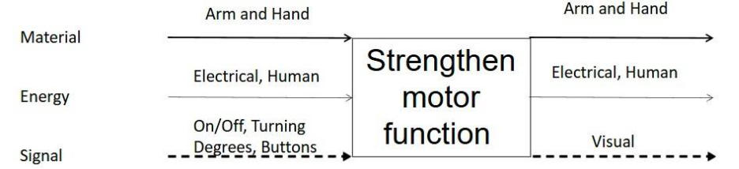

Figure 3: Black Box Diagram

Above, our black box model shows the basic function of our robot. Electrical energy and some human inputs are translated to movement of the robot and the patient’s arm, thus training the user’s motor control. It turns signals from a computer into visual outputs on a screen so the user can identify what the robot is doing.

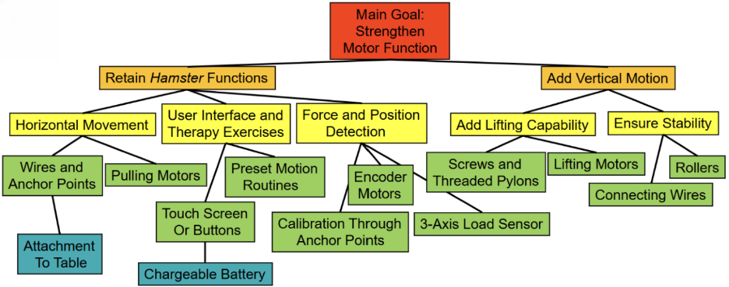

Figure 4: Functional Decomposition

This functional decomposition provides a more in-depth explanation of the device’s actions. The ultimate goal of strengthening motor function is highlighted in red, showing its importance in our design. Next, the orange function aspects show how our design accomplishes two significant goals: reproducing the functions of its *Hamster* predecessor and adding vertical motion. These goals are divided into manageable yellow functions. Each of these is supported by green primary components. Finally, two additional sets of components complete the robot’s array of functions.

**5. Moving Forward**

Some areas that still need to be developed are the codes and equations that will run the Arduino and the Raspberry Pi as well as the communication method between the two. Calculations that will need to be re-run are the battery capacity/voltage as we will be testing the efficiency of the motors and a more precise calculation can then be calculated from experimental data. The position tracking code will also have to be reworked to be able to read the current draw of the motors to tell when the wires are tensioned properly so that the robot can calibrate its position when the anchor points are not perfectly perpendicular to the robot. Code for the Arduino and Raspberry Pi still needs to be developed and tested as well.

**6. References**

[1] “Basic introduction to the IEC 60601 series,” *AAMI CR500:2019; Basic Introduction to the IEC 60601 Series*, Dec. 2019. doi:10.2345/9781570207334.ch1

[2] ANSI/AAMI/IEC 80601-2-78:2020; medical electrical equipment—part 2-78: Particular requirements for basic safety and essential performance of medical robots for rehabilitation, assessment, compensation or alleviation, no. Edition 1, 2019. doi:10.2345/9781570207730

[3] “Product classification,” accessdata.fda.gov, https://www.accessdata.fda.gov/scripts/cdrh/cfdocs/cfpcd/classification.cfm?id=QKC (accessed Sep. 8, 2025).

**7. Appendix**

Wire Tension Validation

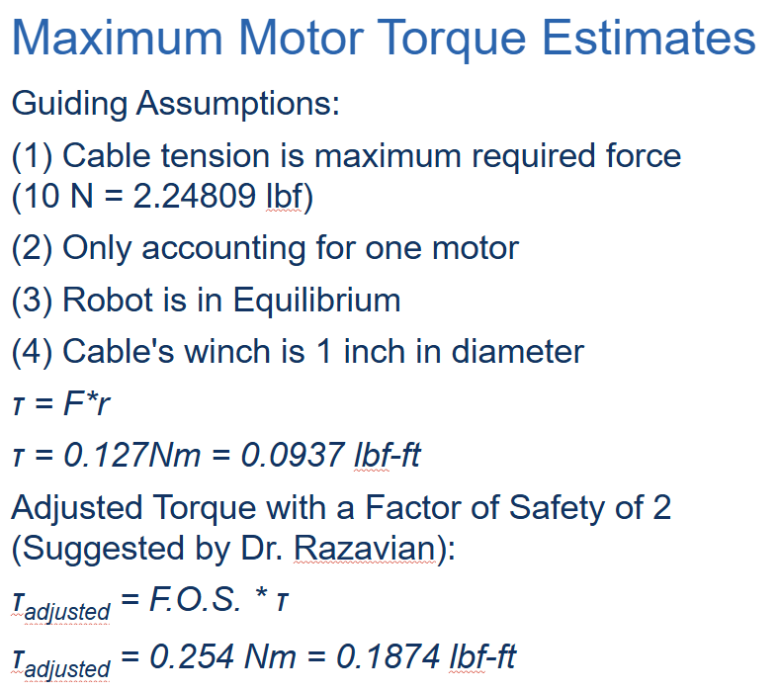

Motor Torque Calculations

Wire Stress Calculations

Four Wire System Validation

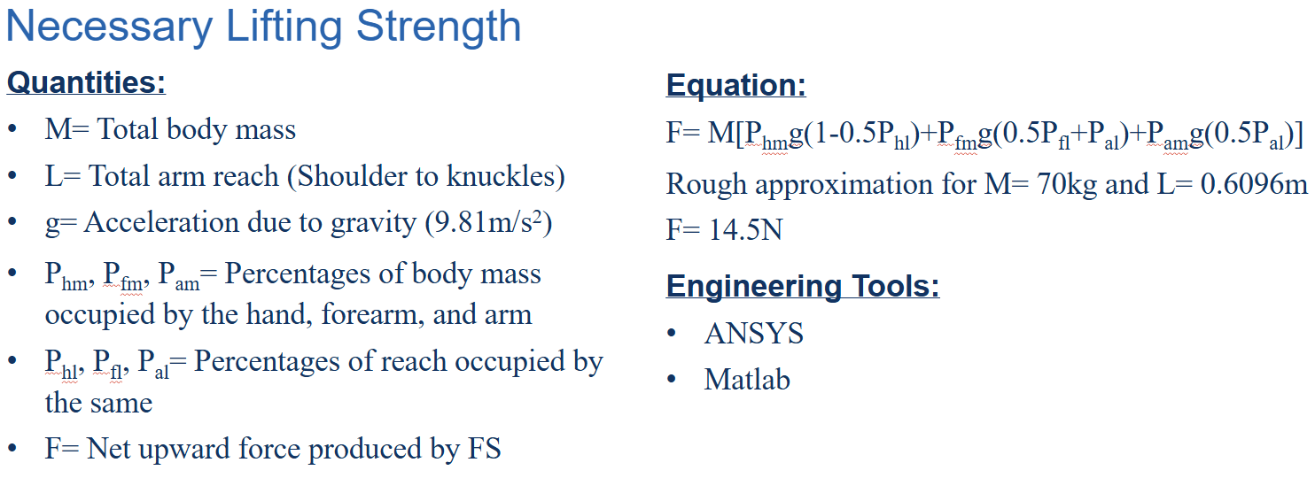

Arm Moment Calculations

Downward Wire Force Calculations

Motor Torque Code

%define reasonable anchor points the further away the better closer gives

%steeper angles iterate on 2 things, moving the robot seeing where wire

%forces are maximum and direction of force combining these 2 gives worst

%case scenario on max torque and select motors accordingly

force = 20; %Newtons, combined force in any direction

radius = 0.005; %meters, radius of pulley

for i=1:201

R = [0.1;0.2;0.3];

A1 = [-0.5;-0.3;0];

A2 = [0.5;-0.3;0];

A3 = [0;0.8;0];

R0 = R.*[1;1;0];

rad(i) = ((i-1)*0.01) * pi()

x_force(i) = cos(rad(i)) * force

y_force(i) = sin(rad(i)) * force

desiredforce(:,i) = [x_force(i);y_force(i);0];

V1 = A1-R;

u1 = V1/norm(V1);

V2 = A2-R;

u2 = V2/norm(V2);

V3 = A3-R;

u3 = V3/norm(V3);

c1 = u1.*(1+[1;1;0]);

c2 = u2.*(1+[1;1;0]);

c3 = u3.*(1+[1;1;0]);

c4 = [0;0;1];

C = [c1 c2 c3 c4]

wireForces(:,i) = lsqnonneg(C,desiredforce(:,i))

maxT = max(wireForces(:,i))

minT = min(wireForces(:,i))

torque = maxT * radius

end